:

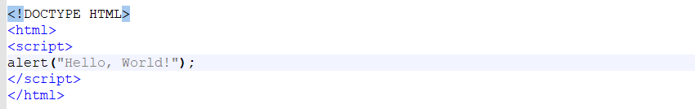

<!DOCTYPE HTML>

<html>

<script>

alert(“Mmmm pretzel bites”);

</script>

</html>

--------------------------------------------------------------

<!DOCTYPE html>

<html>

<body>

<h2>JavaScript Alert</h2>

<button onclick="myFunction()">Try it</button>

<script>

function myFunction() {

alert("I am an alert box!");

}

</script>

</body>

</html>

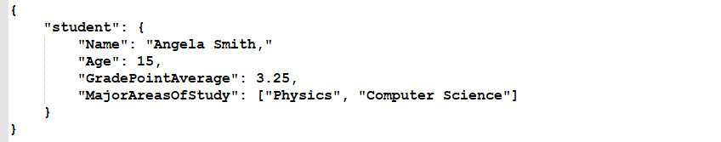  
<!DOCTYPE HTML>

<html>

<body>

<script>

alert("Mmmm pretzel bites");

</script>

</body>

</html>

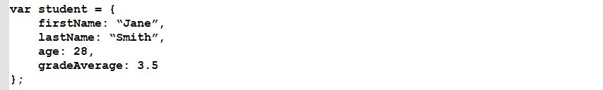

An example could look like this:



Other JavaScript code elements could call this “add” function by specifying its name and passing it two numbers. That could look like this:

https://techacademystorage.blob.core.windows.net/htmlandcss/function2.png

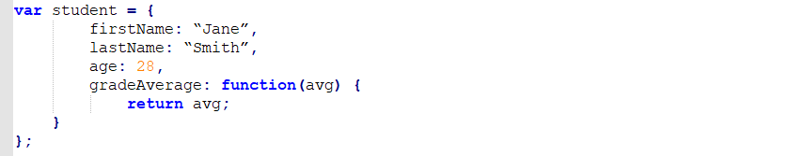

Here, we aren’t setting the property “gradeAverage” to a fixed number of 3.5. Instead, we are setting that property to the value returned by a set of code. Specifically, that code will take in a number (the variable “avg”) and set the value of the “gradeAverage” property to the value of that variable.

Executing that code could look like this:

https://techacademystorage.blob.core.windows.net/htmlandcss/method3.PNG

An “attribute” is a specification that assigns a property (name; characteristic) to something. Basically, an attribute is metadata (data that describes other data).

The element returned by document.getElementById has an Id attribute with a specific value assigned to it. The Id is a variable.

For an example:

https://techacademystorage.blob.core.windows.net/htmlandcss/h1.png

We have assigned the h1 element the Id “Header_1”. To run and display (return) this element, we write:

https://techacademystorage.blob.core.windows.net/htmlandcss/get_element.png

“innerHTML” gets or sets the HTML markup contained within the element.

Document.getElementById is used mainly to control or get information from an element within your code. If it can’t find the element with the specified Id, it will return “null.”

**CREATING A FUNCTION**

Let’s look at creating a function using the document.getElementById method:

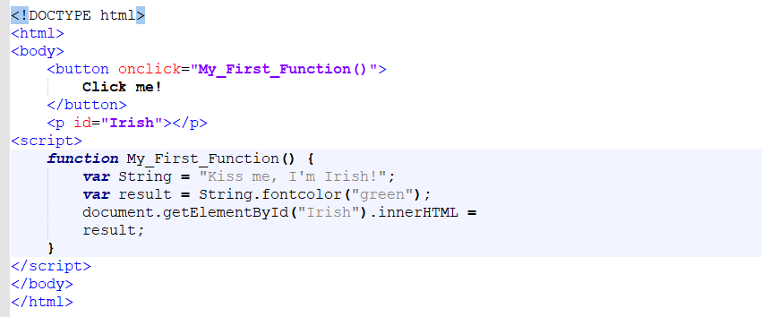

The above code accomplished the following:

* Created a button element.
* Utilized the ID attribute and assigned the button element the value “Irish”.
* Returned the button element by calling the “Irish” value that we assigned earlier (when writing the ID attribute).

Everything inside our curly brackets { } is our function.

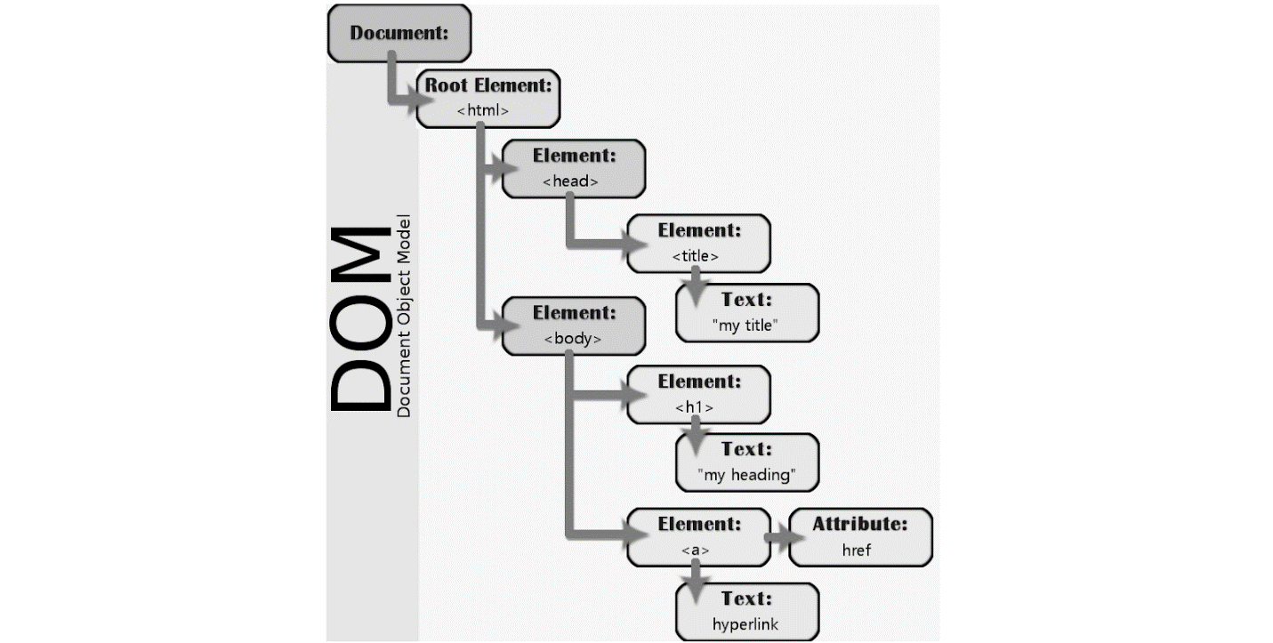

Suppose you wanted to find all paragraph elements in an HTML document. You might use code like this:

https://techacademystorage.blob.core.windows.net/htmlandcss/get_element2.png

The variable called “foo” would now contain a collection of all the paragraph tags in the document.

Many different programming languages can be used to work with the DOM. One of the most common is JavaScript; in fact, the code example above is actually JavaScript.